Lab 28 - Spoofing as a Router

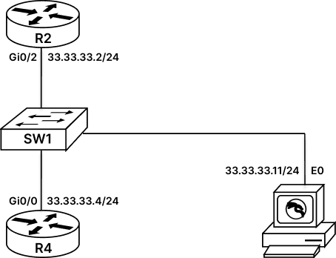

Configure Layer 3 Spoofing
Spoofing is a term used to imitate someone or something. In security, Attackers use this spoofing technique to imitate the identity of genuine source/device and attack victim.
Spoofing in network security can be done at almost every layer, right from layer 2 where we can do MAC based spoofing, layer 3 where we can do IP spoofing up to layer 7 where we can spoof the application as well.
In this lab, we will be using KALI machine (An open source penetration testing tool) to perform Layer 3 based spoof attack. We will start with Layer 3 spoofing of routers, using kali to spoof itself as a router and form neighborship with genuine routers. Then we will use KALI to perform layer 3 route injection attack, which will inject malicious route in routers routing table and finally will configure a simple authentication password on our routers and then using KALI we will perform a brute force attack on our routers to compromise password.
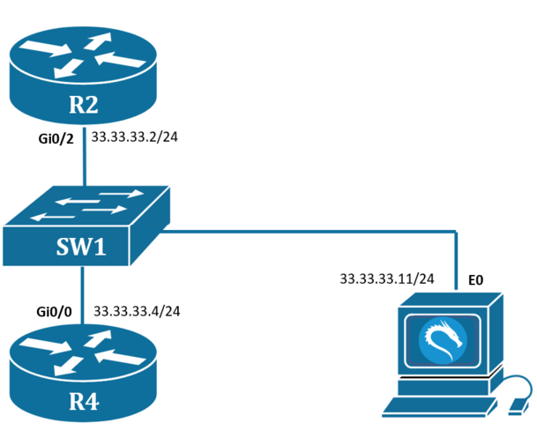
Task 1: Configure IP Address on Routers
Step 1: To start with this lab we will first configure both the routers with relevant IP address.
R2#conf t
R2(config)#int gi0/2
R2(config-if)#ip add 33.33.33.2 255.255.255.0
R2(config-if)#no shutdown
R2(config-if)#exit
R2(config)#int lo1
R2(config-if)#ip add 100.0.0.2 255.255.255.0

----------------------------------------------------

R4#conf t
R4(config)#int gi0/0
R4(config-if)#ip add 33.33.33.4 255.255.255.0
R4(config-if)#no shutdown
R4(config-if)#exit
R4(config)#int lo1
R4(config-if)#ip add 200.0.0.4 255.255.255.0
Step 2: Configure OSPF on R1 and R2.
R2#conf t
R2(config)#router ospf 1
R2(config-router)#network 0.0.0.0 0.0.0.0 area 0

-----------------------------------------------------

R4#conf t
R4(config)#router ospf 1
R4(config-router)#network 0.0.0.0 0.0.0.0 area 0
Step 3: Verify reachability and neighborship.
R2#show ip route
----Output Trimmed-----
33.0.0.0/8 is variably subnetted, 2 subnets, 2 masks
C 33.33.33.0/24 is directly connected, GigabitEthernet0/2
L 33.33.33.2/32 is directly connected, GigabitEthernet0/2
100.0.0.0/8 is variably subnetted, 2 subnets, 2 masks
C 100.0.0.0/24 is directly connected, Loopback1
L 100.0.0.2/32 is directly connected, Loopback1
200.0.0.0/32 is subnetted, 1 subnets
O 200.0.0.4 [110/2] via 33.33.33.4, 00:00:04, GigabitEthernet0/2
R2#200.0.0.4
type escape sequence to abort.
Sending 5, 100-byte ICMP Echos to 200.0.0.4, timeout is 2 seconds:
!!!!!
Success rate is 100 percent (5/5), round-trip min/avg/max = 7/8/11 ms
R2#
Task 2: L3 Spoofing using Kali Linux
Step 1: We will take access of kali machine
username : root
password : rst@12345
From kali machine open terminal and type ‘loki.py’. Loki is a network penetration testing tool.
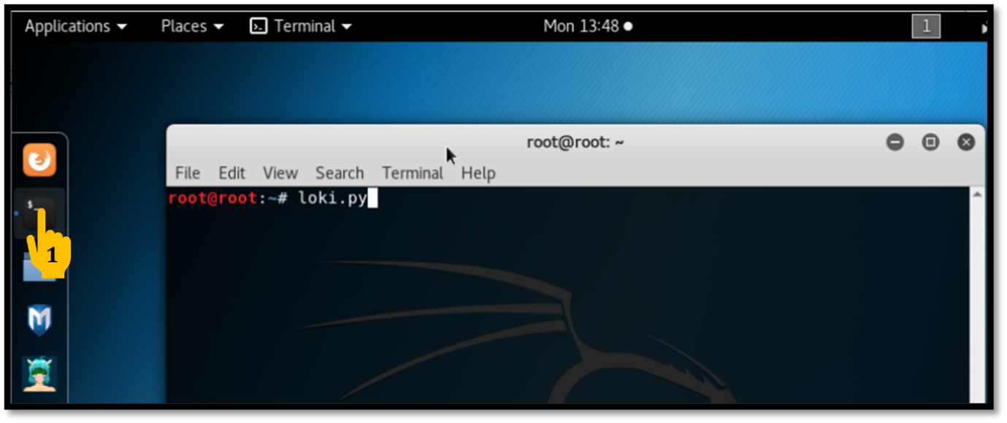
Step 2: Inside loki.py, navigate to RUN and verify the IP of the KALI machines Interface.
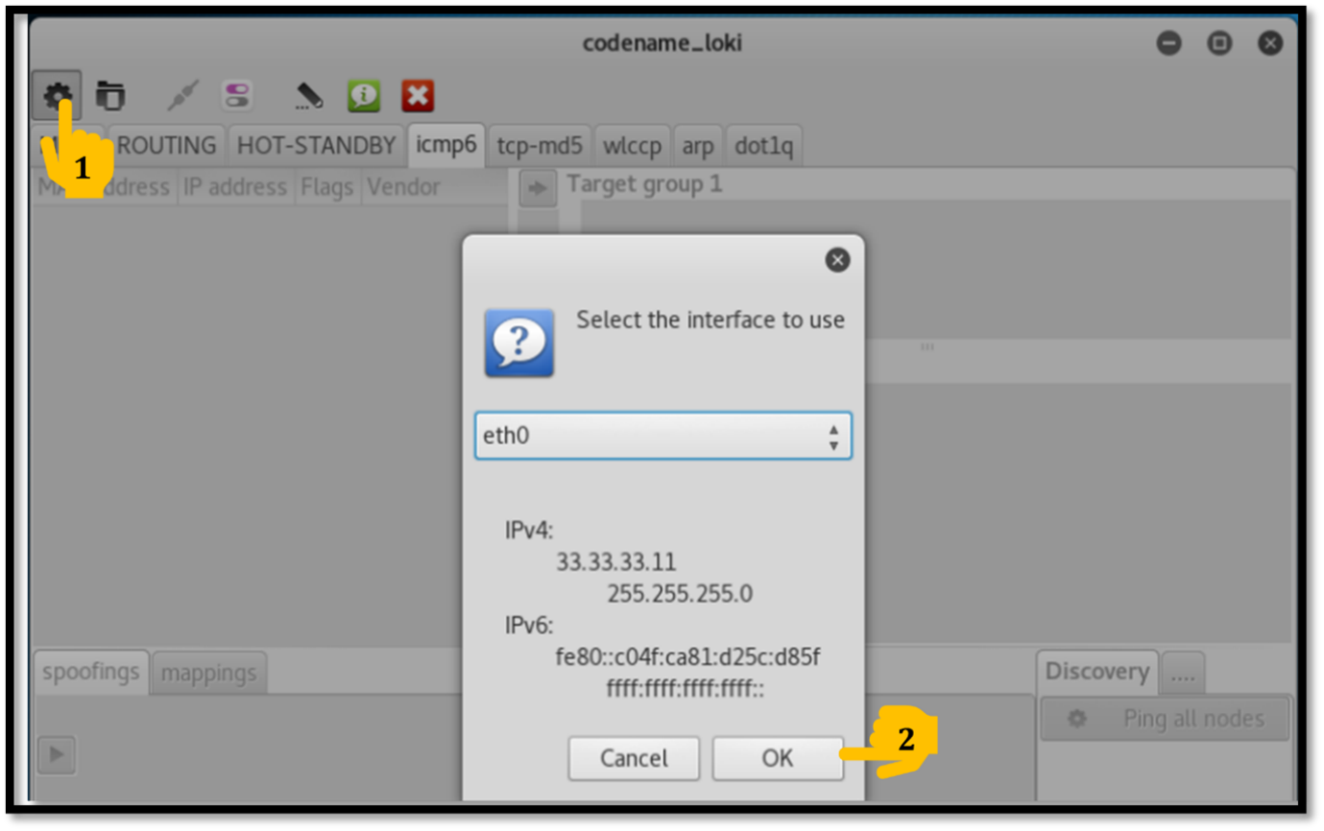
Step 3: Now navigate to Routing > OSPF , here we see that LOKI has discovered two neighbors R2(33.33.33.2) and R4(33.33.33.4).
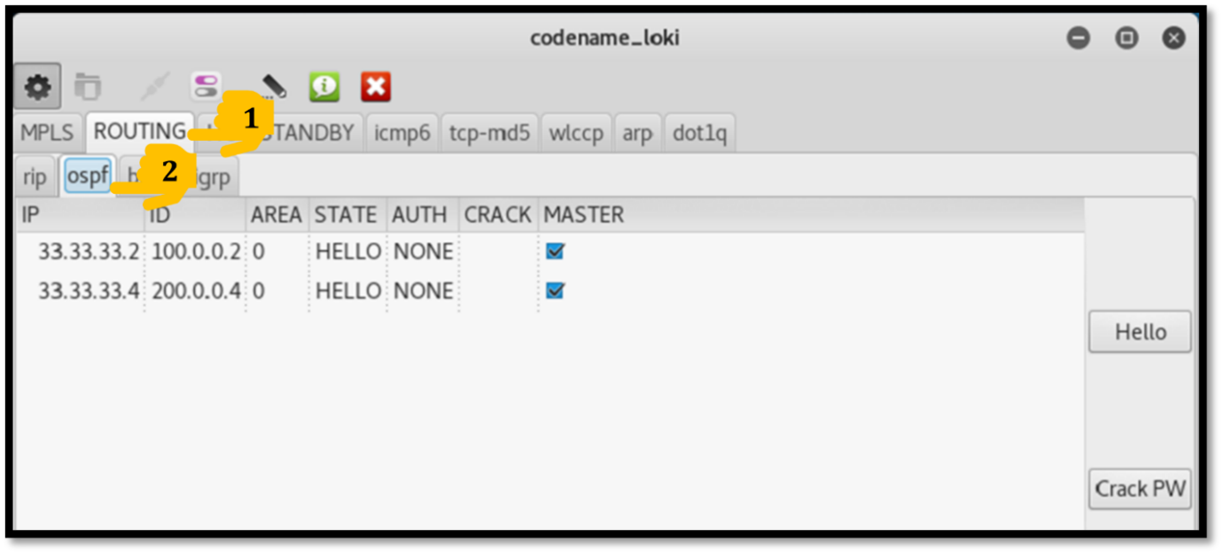
Step 4: Now we will start the attack, where Loki will start spoofing itself as a router and form neighborship with R2 and R4 router.
To start spoofing, first go to Loki.py and uncheck the master tab for both the routers, this will enable us to use these routers for spoofing and then we will change the AUTH_TYPE to NONE and click on Hello.
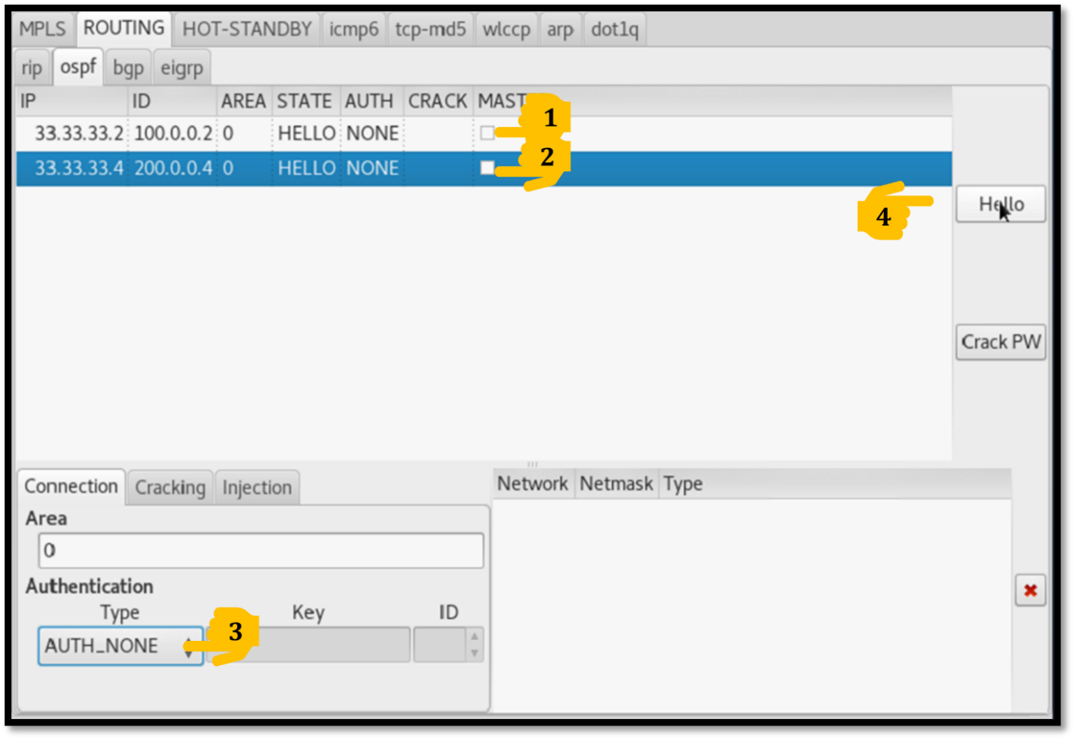
Step 5: Now verify the neighborship on Loki, we will now see that the ‘STATE’ has been changed from ‘HELLO’ to ‘FULL’.
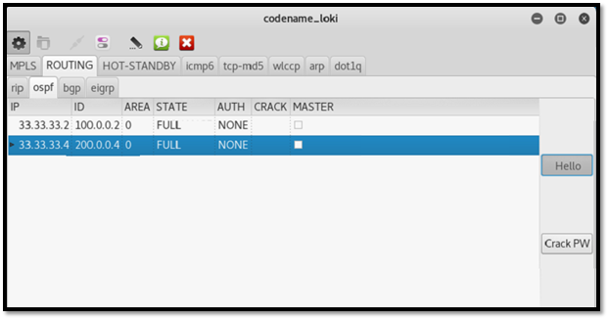
Step 6: Now verify neighborship on routers as well
R2#show ip ospf nei
Neighbor ID Pri State Dead Time Address Interface
33.33.33.11 1 FULL/DROTHER 00:00:39 33.33.33.11 GigabitEthernet0/2
200.0.0.4 1 FULL/DR 00:00:34 33.33.33.4 GigabitEthernet0/2
R2#
Here we can see that Loki has successfully spoofed itself as a router and formed neighborship with my routers.
Task 3: L3 Route Injection using Kali Linux
Step 1: After forming neighborship with routers now inside Loki application go to Injection Tab and inject following network
Network : 1.1.1.0
Netmask: 255.255.255.0
Network Type: Type_Router_links
and then hit “Add”.
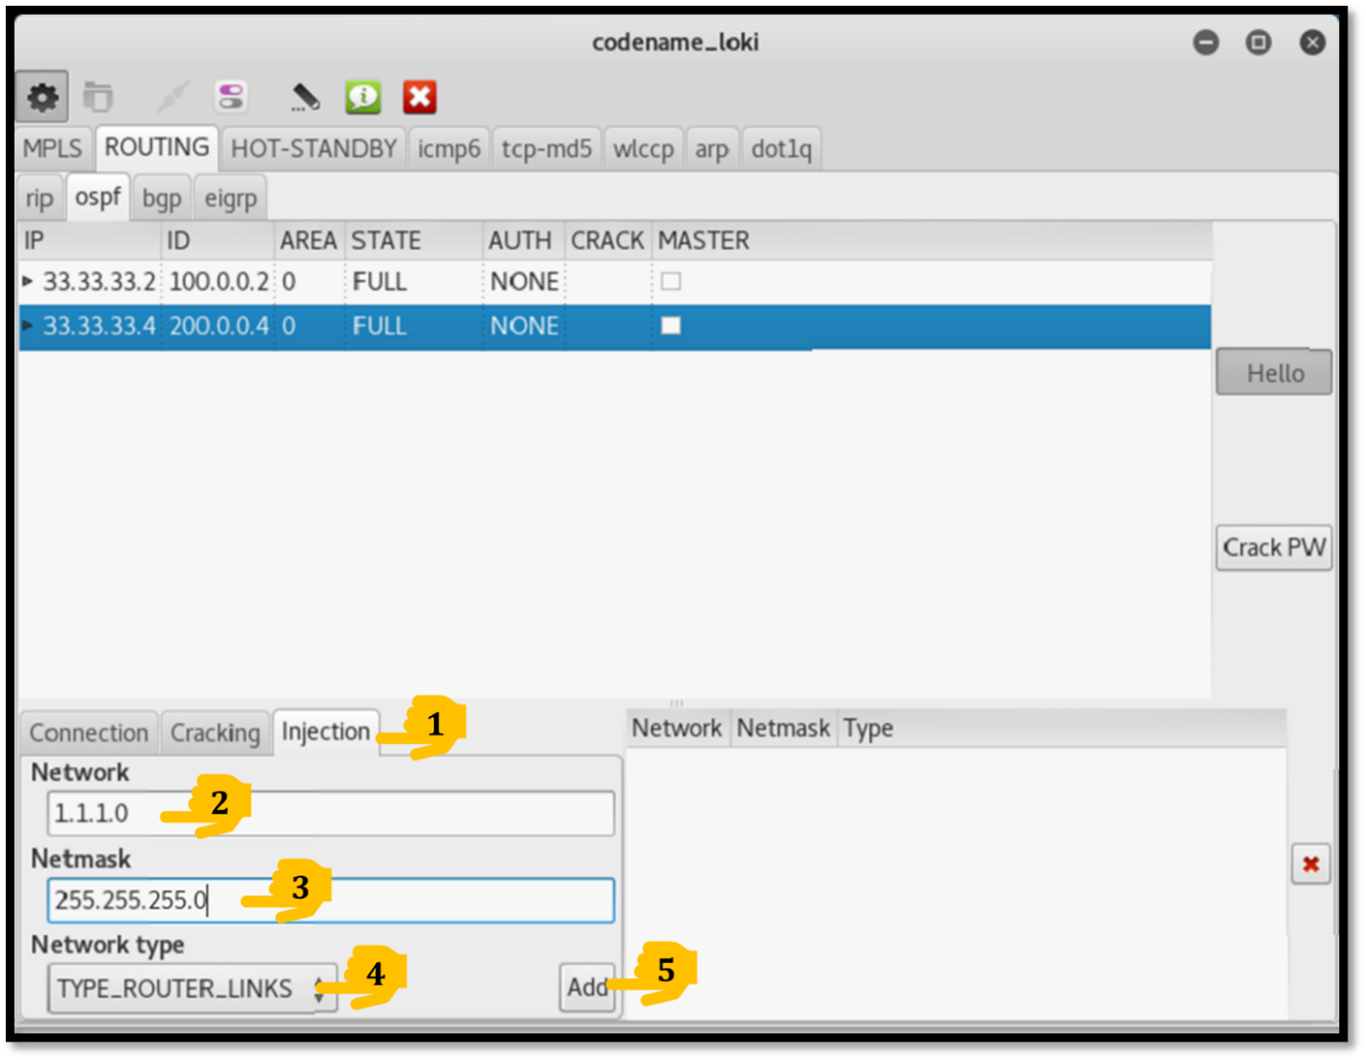
Step 2: Now verify routes in routers routing table, here we can see 1.1.1.0 route is injected via Kali into routers routing table.
R2#sh ip route
-----------------------Output Trimmed----------------------------------
1.0.0.0/24 is subnetted, 1 subnets
O 1.1.1.0 [110/2] via 33.33.33.11, 00:00:01, GigabitEthernet0/2
33.0.0.0/8 is variably subnetted, 2 subnets, 2 masks
C 33.33.33.0/24 is directly connected, GigabitEthernet0/2
L 33.33.33.2/32 is directly connected, GigabitEthernet0/2
-----------------------Output Trimmed-----------------------------------
Task 4: Password Breaking using Kali Linux
Step 1: Close “Loki.py” in kali machine.
Step 2: Now configure OSPF Authentication using simple password “key” between R2 and R4 router. To build authentication type the following command on R2 as well as R4 router.
R2#key chain RST
R2(config-keychain)#key 1
R2(config-keychain-key)#key-string key
R2(config-keychain-key)#cryptographic-algorithm md5
R2(config-keychain-key)#exit
R2(config-keychain)#exit
R2(config)#int gi0/2
R2(config-if)#ip ospf authentication key-chain RST
-------------------------------------------------------------
R4#key chain RST
R4(config-keychain)#key 1
R4(config-keychain-key)#key-string key
R4(config-keychain-key)#cryptographic-algorithm md5
R4(config-keychain-key)#exit
R4(config-keychain)#exit
R4(config)#int gi0/0
R4(config-if)#ip ospf authentication key-chain RST
Step 3: Now go Kali machine, open terminal, and type loki.py
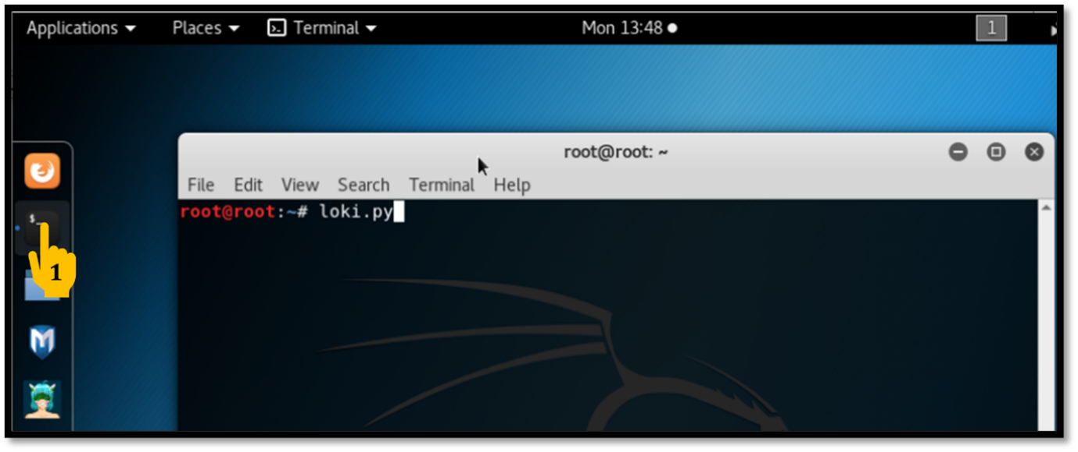
Step 4: Now inside Loki.py click on RUN > OK
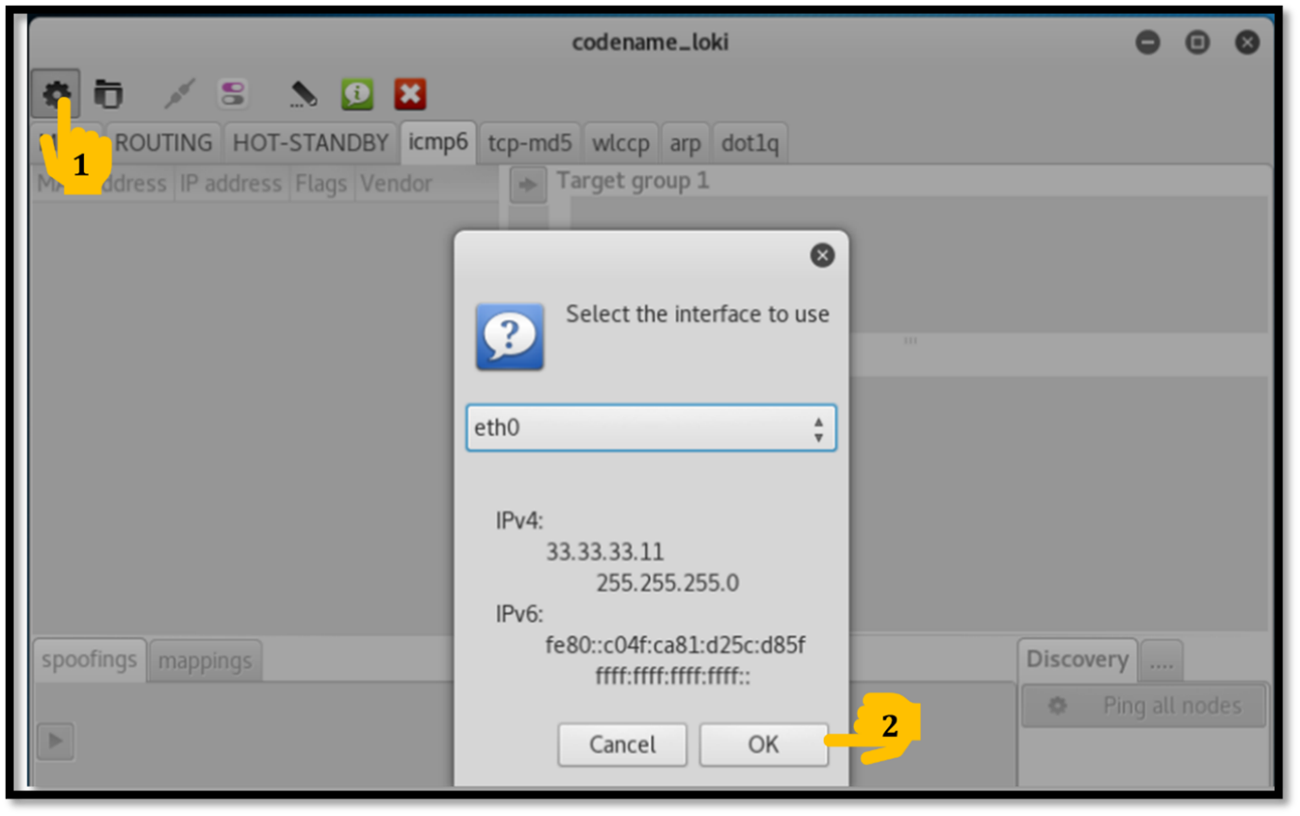
Step 5: Now go to Routing > OSPF and verify that we can see both the routers and notice that the AUTH is changed to CRYPT. Loki has figured out that both the routers are not using authentication to form neighborship.
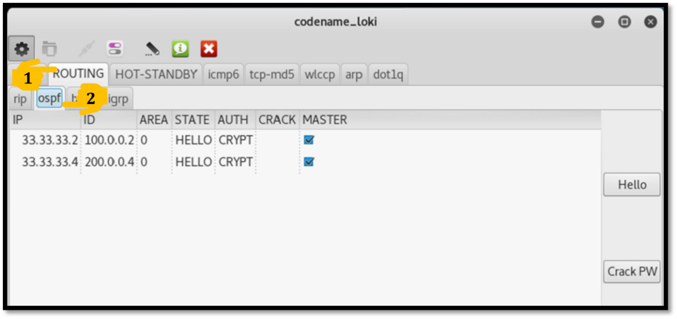
Step 6: Now we will break the authentication by first cracking the password used for the authentication. First we will untick the Master tab locking devices and then we will go to ‘Cracking’ tab then we will select ‘brute force’ an then we will click on ‘Crack PW’.
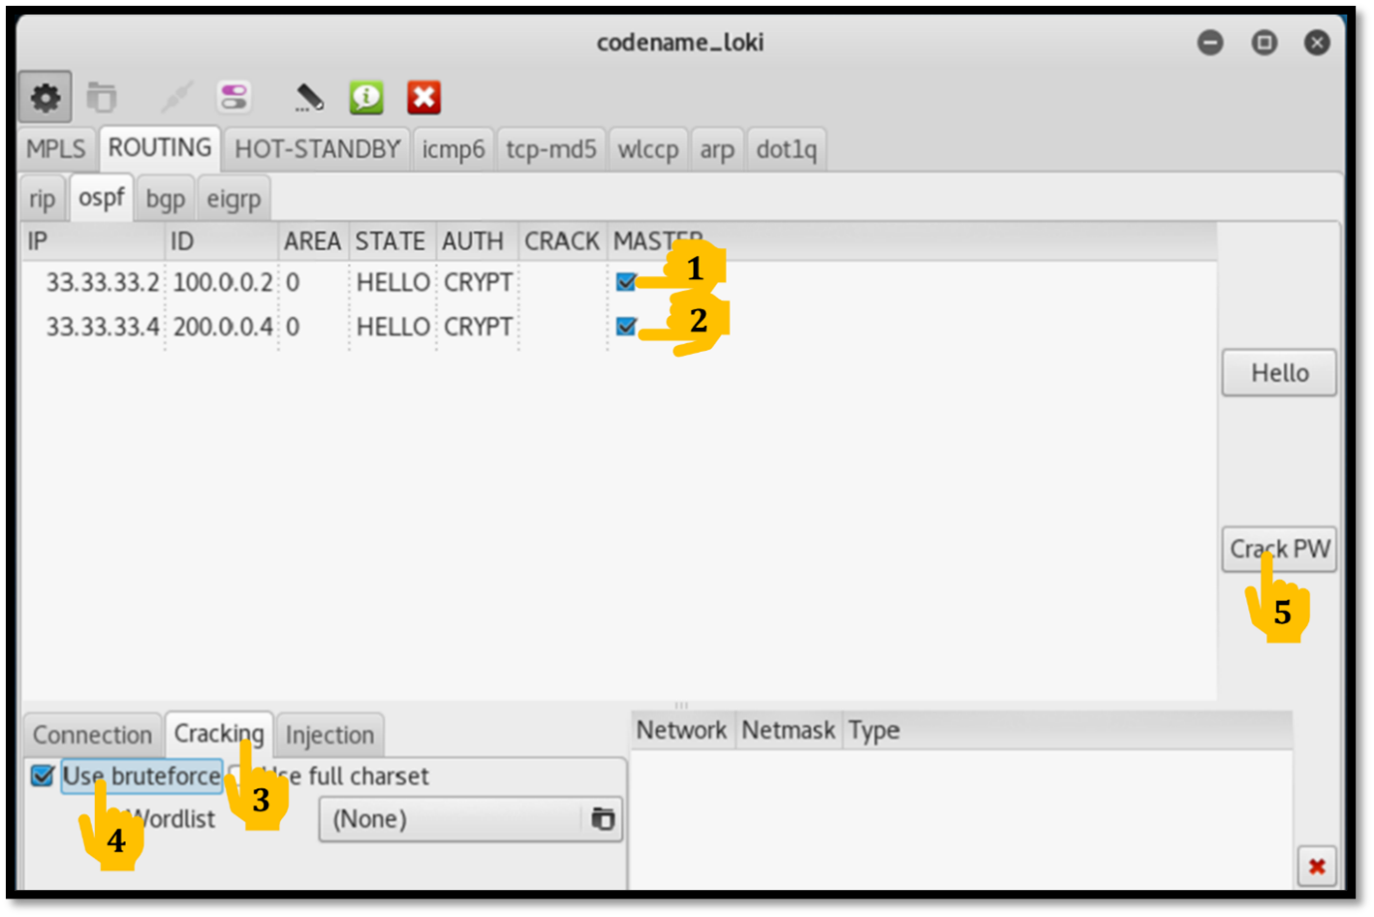
Step 7: Now verify under CRACK tab, we can see the cracked password that is “key”.
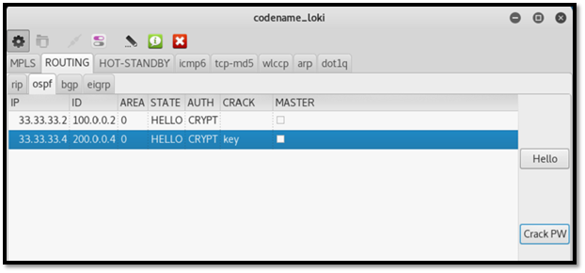
Step 8: Now using this password we will again form neighborship with routers, to do this now we will go to Loki, Click on Connection >
Area: 0
Authentication: AUTH_CRYPT
Key: Key
ID: 1
and then click Hello.
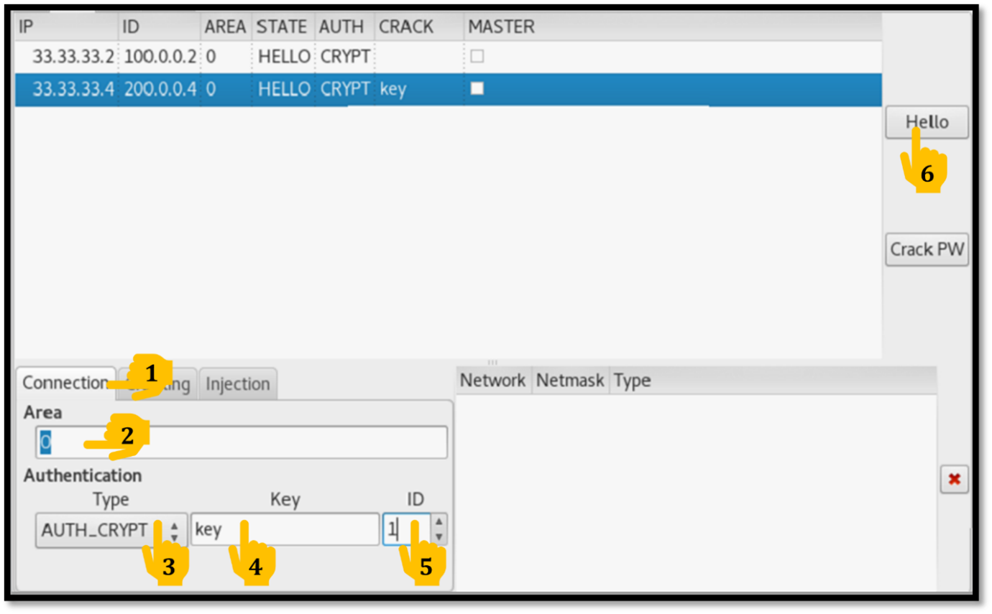
Step 9: Verify the STATE in Loki, it would have changed to ‘FULL’.
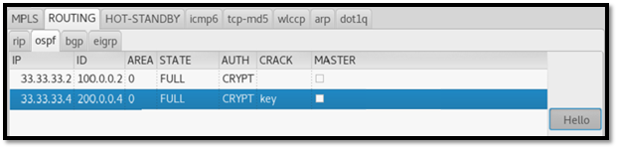
MITIGATION: We should always use strong encryption password, strong algorithm like SHA instead of MD5 while forming neighborship on routers. Complex passwords and encryptions make it difficult for tool like Loki to crack.

